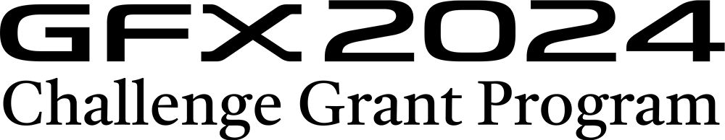

2024富士无反中画幅GFX系列全球挑战项目（中国区）申请表
GFX Challenge Grant Program 2024 Application Form China

感谢您参与项目挑战，请用中英文填写表格信息及展示您的代表作，以PDF格式（文件：<10M）上传至报名链接：https://gfx-challenge-program.baiwei.org/ Thank you for participating in the project challenge. Please fill in the form information and display your representative work in Chinese and English, and upload it to the registration link: https://gfx-challenge-program.baiwei.org/ in PDF format (file: <10M)
参
个人信息 Personal Information
姓名:  Name | 所在城市:  City
联系手机:  Mobile Phone | 联系邮箱:  E-Mail
您目前使用的相机品牌与具体机型（如使用多款相机，请填写您目前使用最多的品牌。请放心，回答不会影响参赛）
What is your main camera currently? Fill in brand that you use the most currently. Please note this answer will not affect the selection.

参赛信息 Entry Information
Q1: 您的项目概要：设计想法以及创作背景（<100字）Please summarize (max of 100 words) your project. With this, a reader should be able to understand the concept of your project and the context of imagery you are trying to achieve
Q2:您的预计项目日程：日程规划（准备期至项目完成）Schedule / Timeline
Please summarize the currently estimated schedule and milestones for your project from commencement (preparation) through completion.
Q3:项目预算：如何使用创作资金开展项目？ Budget
Please summarize how any awarded grant funds would be used to carry out your project.
个人优秀作品展示（<6张）Personal excellent photography exhibition (<6 photos)
个人履历Personal resume

